Informed Consent Form for Participation in a Research Study

**Study Title**:LEFT Bundle Pacing vs Standard RV Pacing for Heart Failure (LEFT-HF)

**Principal Investigator**: Dr. Habib Khan

London Heart Rhythm Program

University Hospital, London Health Sciences Centre

519-663-3746

**Emergency Contact Number** (24 hours / 7 days a week):

Present to your local emergency department. Let them know you are participating in the LEFT-HF study and to contact the EP attending physician at LHSC.

**Sponsor:** The Research Institute of the McGill University Health Centre

**Grant in Aid:** Canadian Institutes of Health Research and Heart and Stroke Foundation

**INTRODUCTION**

You are being invited to participate in a clinical trial (a type of study that involves research). You are invited to participate in this study because you have been diagnosed with electrical heart block, also known as AV block. Heart block means that the electrical signals that controls the top and bottom of your heart are no longer communicating with each other. This causes your heart to beat either too slowly or too inefficiently and will prevent the heart to pump blood effectively to the rest of your body. Your doctor has recommended a pacemaker implantation to treat this condition.

This consent form provides you with information to help you make an informed choice. Please read this document carefully and ask any questions you may have. All your questions should be answered to your satisfaction before you decide whether to participate in this research study.

Please take your time in making your decision. You may find it helpful to discuss it with your friends and family.

Taking part in this study is voluntary. You have the option to not participate at all or you may choose to leave the study at any time. Whatever you choose, it will not affect the usual medical care that you receive outside the study*.*

**IS THERE A CONFLICT OF INTEREST?**

There are no conflicts of interest to declare related to this study.

If you would like additional information about the funding for this study, or about the role of the doctor in charge of this study, please speak to the study staff or the Patient Relations Office at LHSC at (519) 685-8500 ext. 52036

**WHAT IS THE BACKGROUND INFORMATION FOR THIS STUDY?**

Normally, electrical signals travel from the upper chambers of your heart (atria) to the lower chambers (ventricles). The AV node is a cluster of cells that connect the electrical activity, like a bridge, from the top chambers of your heart to the bottom chambers. If you have heart block, the electrical signal does not travel through the AV node to the ventricles. The delay or block can occur on the pathway that sends electrical impulses either to the left or the right side of the bottom chambers of your heart. The result is that your heart cannot pump blood through its chambers and out to the body as a normal heart would.

The standard or usual treatment for heart block is a pacemaker. Pacemakers are life-saving devices that allow the heart to pump in an organized manner. The pacemaker sends small electrical impulses to the heart muscle to maintain a suitable heart rate or to stimulate the lower chambers of the heart (ventricles). A pacemaker has two parts. One part, called the pulse generator located in front of the shoulder once implanted, contains the battery and the electronics that control your heartbeat. The other part is one or more leads to send electrical signals to your heart. Leads are small wires that run from the pulse generator to your heart.

When placing a pacemaker, the doctor makes a small incision near the shoulder. He/she guides a small wire(s) through the incision leading into a vein near the collarbone. Then he/she leads the wire(s) through the vein to the heart. An X-ray machine is helping guide the doctor through the process. Using the wire, the doctor attaches an electrode to the heart’s right ventricle (lower chamber of the heart). A second lead is then attached to the heart’s right atrium (upper chamber of the heart). The other end of the wire(s) is attached to a pulse generator. This contains the battery and electrical circuits.

Patients who have heart block become dependent on the pacemaker to deliver electrical signals. If a patient is completely dependent on the electrical signals delivered on the bottom chamber, they are at risk of developing a weakening of their heart muscle. This can occur in up to 20-25% of patients. This weakening of the heart is called ‘pacing-induced cardiomyopathy’ and is associated with the development of heart failure. Heart failure is a weakening of the heart muscle which causes water on the lungs, increased emergency department visits, hospitalizations and even higher mortality. Symptoms of heart failure include shortness of breath, fatigue, weakness, and a decreased ability to perform regular activities. If pacing-induced cardiomyopathy occurs during follow-up, patients may need a second procedure to add a wire to the left side of the heart (“cardiac resynchronization therapy”) to re-organize the electrical impulses and improve the heart function.

Left bundle branch pacing (LBBP) is a novel approach to place a pacemaker that attempts to prevent the risk of pacing-induced cardiomyopathy and prevent heart failure. The pacemaker generator (battery) is identical to the standard pacemaker. The only difference is the location of where the ventricular (lower chamber) wire is placed. All wires are Health Canada approved and have been in use for many years.

This study is being done because we don’t know whether this new pacemaker wire position is better than the usual location. We hope that the new position will decrease the chance of heart failure and pacing-induced cardiomyopathy, which is why highly specialized physicians (electrophysiologists) are researching this procedure.

**WHY IS THIS STUDY BEING DONE?**

The purpose of this study is to compare two pacemaker placement strategies (see **Figure 1** below):

1. Standard right ventricular pacing (control group)

B) Left bundle branch pacing (LBBP) (experimental group).

**Figure 1.** Location of the wires in the standard vs LBBP group.

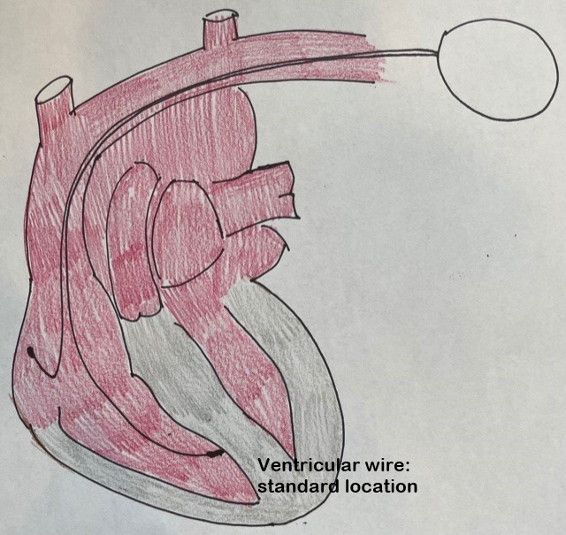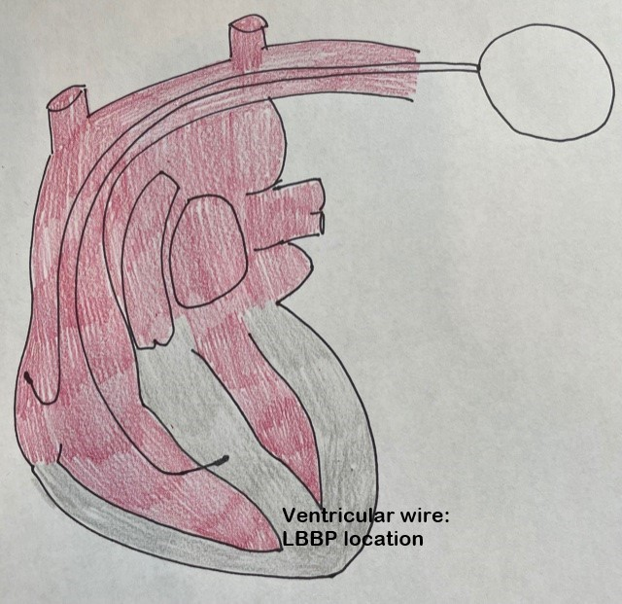

**WHAT OTHER CHOICES ARE THERE?**

You do not have to take part in this study in order to receive treatment or care. An alternative to the procedures described above is not to participate in the study.

Please talk to your usual doctor or the study doctor about the known benefits and risks of the other options you may receive outside the study before you decide to take part in this study.

**HOW MANY PEOPLE WILL TAKE PART IN THIS STUDY?**

It is anticipated that about 1300 people will take part in this study, from research sites located in Canada.

This study should take approximately 5 years to complete and the results should be known in about 6-12 months.

**WHAT WILL HAPPEN DURING THIS STUDY?**

When participating in this research project, you will be assigned to one of the following groups:

**Group 1:** Standard right ventricular pacing (control group)

**Group 2:** Left bundle branch pacing (LBBP) (experimental group).

This study is randomized which means that you will be assigned to one of the groups. You may not choose the group to which you will be assigned; this process is done randomly like flipping a coin. There is no way to predict which group you will be assigned to. You will have an equal chance (50%, or 1 in 2) of being placed in either the control or experimental group. You may be informed of which group you are in, if required.

During your participation in this research study, the study doctor or a qualified member of the research team will conduct the following tests and procedures:

| **DESCRIPTION OF STUDY PROCEDURES** | |
| --- | --- |
| **Procedure** | **Description** |
| Review of your medical chart | The study doctor or a member of the research team will collect information from your medical chart, such as your medical and cardiovascular history. |
| Medication and Adverse events Assessments | The study doctor or a member of the research team will ask you about all the medications that you are currently taking. The study doctor or a member of the research team will ask you about how you are feeling and if you have any side effects (adverse events). |
| ECG (electrocardiogram) | An ECG is a test that measures the electrical activity of the heart. Electrodes (small, plastic patches that stick to the skin) are placed at certain spots on the chest, arms, and legs. The electrodes are connected to an ECG machine by lead wires (or cables). |
| Echocardiography | Echocardiography is a test that uses sound waves to produce images of your heart. A technician will spread gel and move a probe around your chest to produce images of your heart. |
| Implant procedure | The nurse will explain in detail and give you instructions to prepare for the pacemaker implantation including what to expect. |
| Device Interrogation | The pacemaker will need to be ‘interrogated’ by a specialized team. This includes testing the wires to make sure they are working well, assessing the battery life of the pacemaker, and making changes to the programming where necessary. |
| Blood draw | A needle is used to take blood from a vein for laboratory tests to help the study doctor understand your health status. This blood test (5mL that is about 1 teaspoon) is for the analysis of NT-Pro BNP (a heart failure indicator).  If you are a woman of childbearing age, you will undergo an additional blood test or urine test to determine if you are pregnant. You cannot participate in this study if you are pregnant. |
| Quality of life questionnaires | Quality of life questionnaires will help to determine how you are impacted by the pacemaker.  The questionnaires will take approximately 10 minutes to complete. You may skip any questions that make you uncomfortable or that you do not wish to answer. *These questionnaires would not be asked if you were not participating in a study.* |

The schedule of procedures for each visit is listed below:

|  |  |  |  |  |  |  |
| --- | --- | --- | --- | --- | --- | --- |
| **SCHEDULE OF STUDY PROCEDURE** | | | | | | |
| **Procedure** | **Baseline Visit** | **Implant** | **6-month Follow-up** | **12-month Follow-up** | **24-month Follow-up** | **36 month Follow-up** |
| Informed Consent | X |  |  |  |  |  |
| Medical History/ Cardiovascular History | X* |  | X* | X* | X* | X* |
| Medication Assessment | X* | X* | X* | X* | X* | X* |
| Blood draw** | X* |  |  |  | X* | X* |
| Echocardiogram | X* |  |  | X* | X* | X* |
| Device Interrogation |  | X* | X* | X* | X* | X* |
| Adverse events  assessment |  | X | X | X | X | X |
| 12 lead ECG | X* | X* | X* | X* | X* | X* |
| Quality of life Questionnaire | X |  |  | X | X |  |

*Standard of Care. Note that all follow-ups are routine, part of standard of care for post pacemaker implantation follow-up.

**If you are a woman of childbearing age, you will undergo an additional blood test to determine if you are pregnant.

**WHAT ARE THE RESPONSIBILITIES OF STUDY PARTICIPANTS?**

If you choose to participate in this study, you will be expected to:

* Tell the study doctor or research study staff about your current medical conditions.
* Tell the study doctor or research study staff about all prescription and non-prescription medications and supplements, including vitamins and herbals, and check with the study doctor before starting, stopping or changing any of these. There are no contraindications to using specific medications, natural products or other substances beyond what is already recommended for standard right ventricular pacemaker implants (control group). However, if there is a change in your medications, these will be recorded at your next follow-up visit.
* Tell the study doctor or research study staff if you are thinking about participating in another research study. While participating in this research study, you should not take part in any other research project without approval from the Principal Investigator of each study. This is to protect you from possible injury.
* Keep you study appointments. If it is necessary to miss an appointment, please contact the study doctor or research study staff to reschedule as soon as you know you will miss the appointment.
* Tell the study doctor or research study staff about any side effects, doctor visits, or hospitalizations that you may have.

**HOW LONG WILL PARTICIPANTS BE IN THE STUDY?**

Your participation in this research project will last approximately 5 years with a minimum follow-up of 36 months and will include 5 visits. Each study visit will take approximately 1 hour. The number of follow-up visits is identical as for routine pacemaker follow-up (i.e., for a patient not in the study).

**CAN PARTICIPANTS CHOOSE TO LEAVE THE STUDY?**

Your participation in this study is voluntary. You can choose to end your participation in this research (called withdrawal) at any time without having to provide a reason. If you choose not to participate, you will still have the standard pacemaker implanted as planned to treat your heart block. Your study doctor will discuss these options with you.

Information that was recorded before you withdrew will be used by the researchers for the purposes of the study, but no information will be collected after you withdraw your permission. We may ask to follow you via telephone or medical records as per your visit schedule to obtain vital status, however you are free to decline this as well.

If tests have already been done on your sample(s) it will not be possible to withdraw those results. However, no further testing will be done.

**CAN PARTICIPATION IN THIS STUDY END EARLY?**

Your participation on the study may be stopped early, and without your consent, for reasons such as:

* The study intervention does not work for you
* You are unable to tolerate the study intervention
* You are unable to complete all required study procedures
* New information shows that the research is no longer in your best interest
* The study doctor no longer feels this is the best option for you
* The research team decides to stop the study
* The research ethics board withdraws permission for this study to continue

If you are removed from this study, the research team will discuss the reasons with you and plans will be made for your continued care outside of the study.

**WHAT ARE THE RISKS OR HARMS OF PARTICIPATING IN THIS STUDY?**

Participation in this study may involve risks to you. Complications related to pacemaker surgery for both control group and experimental group are uncommon (see below table entitled “Risks Associated with the Research Procedures” for specific risk occurrences). These include:

* infection near the site in the heart where the device is implanted
* swelling
* bruising or bleeding at the pacemaker site
* blood clots near the pacemaker site
* damage to blood vessels or nerves near the pacemaker
* collapsed lung (pneumothorax)
* movement (shifting) of the device or leads
* perforation of the heart during placement of the leads

The pacemaker devices and leads (wires) used in this study are approved by federal agencies worldwide, including Health Canada , and both types of lead placement (standard and LBBP) are performed for patients outside of research at this institution.

The pacemaker implantation procedure for both experimental (LBBP) and control (standard pacemaker) groups are nearly identical. The difference is only where the bottom wire is placed. The additional risks associated with LBBP may include a longer time of procedure (up to 30 minutes more), and perforation of the wall between the right and left lower chambers (interventricular septum). In all cases of perforation, the wire is withdrawn and placed in a different location. Only a highly experienced electrophysiologist will be performing the procedure. We may not know all of the discomforts, side effects and other possible risks associated with implantation of a left bundle pacing lead (LBBP).

Therefore, if you have noticed side effects, whatever they may be, during this research study, you must tell the study doctor immediately, regardless of whether you think these effects are related to the study procedure. Even once your participation in the study is over, do not hesitate to contact the study doctor if you experience a side effect that may be linked to the procedure.

The study doctor and members of his or her team will answer any questions that you may have regarding the risks, discomforts and side effect associated with this study. Also, at each visit, the study doctor and members of his or her team will ask you questions about any side effects you may have experienced.

**Risks Associated With the Research Procedures**

| **Complication with the placement of the pacemaker** | **Experimental group: LBB pacing** | **Control group: Standard RV pacing** |
| --- | --- | --- |
| Electrode displacement | <2% | <2% |
| Lead electrical dysfunction | <1% | <1% |
| Infection | * 0.6% | 0.6% |
| Clinically significant hematoma | * 1.2% | 1.2% |
| Pneumothorax | * 0.5% | 0.5% |
| Cardiac perforation | * 0.3% | 0.3% |
| Subclavian/other related thrombosis | * 0.2% | 0.2% |

**\*** Expected to be equivalent to standard RV pacing.

**Blood draw:** The risks associated with taking blood samples include mild pain, dizziness, fainting, bruising, bleeding, and in rare cases, blood clots and infection.

**Electrocardiogram (ECG):** Your skin may react to the adhesive patches that attach the sensors (electrodes) to your chest during ECG. This skin irritation usually disappears when the patches are removed.

**Pacemaker interrogation:** You may feel your heart beating during the pacemaker interrogation and testing (routine testing).

**Echocardiogram**: You may feel momentary soreness during imaging from the ultrasound probe on your chest.

You should inform your study doctor or a member of his/her team as soon as possible if you have any unusual symptoms as it could affect your health. You can contact them at the phone number listed. In case of emergency (evening, night, weekend and holidays), report any side effects or injury related to the device, you must go to an emergency room as needed.

**Risks associated with pregnancy:** Participation in this study may include risks, known or unknown, for pregnant women, unborn children or to children of breastfeeding women. Consequently, pregnant or breastfeeding women cannot take part in this project.

If you are a woman of childbearing potential, you must undergo a pregnancy test before your pacemaker implant and/or start participating in the study.

Should you suffer harm of any kind following any procedure related to this research study, you will receive all the care and services required by your state of health.

By agreeing to participate in this research study, you are not waiving any of your rights nor discharging the doctor in charge of the study, the sponsor, or the institution of their civil and professional responsibilities.

**WHAT ARE THE BENEFITS OF PARTICIPATING IN THIS STUDY?**

You may or may not personally benefit from your participation in this research project. However, we hope that the study results will contribute to the advancement of scientific knowledge in this field and help us find better treatments for patients.

**HOW WILL PARTICIPANT INFORMATION BE KEPT CONFIDENTIAL?**

If you decide to participate in this study, the research team will only collect the information they need for this study.

Records identifying you at this centre will be kept confidential and, to the extent permitted by the applicable laws, will not be disclosed or made publicly available, except as described in this consent document.

Authorized representatives of the following organizations may look at your original (identifiable) medical records at the site where these records are held, to check that the information collected for the study is correct and follows proper laws and guidelines.

* The Research Institute of the McGill University Health Centre, the Sponsor of this study.
* Population Health Research Institute (PHRI), the Central Coordinating Center.
* The research ethics board who oversees the ethical conduct of this study.
* This institution and affiliated sites, to oversee the conduct of research at this location.
* The Quality Assurance and Education Officers from Lawson Health Research Institute (Lawson) may audit this research study for quality assurance purposes
* A Data and Safety Monitoring Board (DSMB) and others authorized to monitor the conduct of the study.
* Representatives of companies/institutions, including Medtronic Inc. and Heart and Stroke Foundation, working on the study on behalf of the sponsor may have access to, inspect and review your information during and after the study for verification or clinical and scientific research procedures and/or data.
* As part of your routine care (unrelated to study participation) you will have electrocardiograms and transthoracic echocardiograms before this study begins, and again at 12,24 and 36 months. Sometimes these imaging procedures are done at a different hospital or clinic, and if that happens the research team will ask the imaging site to send your images here so that you don’t need to repeat these tests. The research team will do this by sharing personal health information with the imaging site. This information might include your name, date of birth, telling them about your participation in this study and the types of images they need copies of, and a copy of this consent form with your name and signature. This informed consent form may be kept by the imaging site, and may be added to your medical records there. Whenever possible, the imaging site will send your images to this hospital without your identifying information (e.g., your name) on it, but sometimes it is not possible to remove your identifying information from your scans. By signing this consent form, you give this hospital permission to share this information with the imaging site. You may be asked to fill out another form to give the imaging site permission to share your images with this hospital.

Information that is collected about you for the study (called study data) may also be sent to the organizations listed above. Representatives of Clinical Trials Ontario, a not-for-profit organization, may see study data that is sent to the research ethics board for this study. Your name, address, email, or other information that may directly identify you will not be used. The records received by these organizations may contain your participant ID, sex and date of birth.

Studies involving humans sometimes collect information on ethnicity because these characteristics may influence how people respond to different interventions. Providing information on your ethnic origin is optional.

Communication via e-mail is not absolutely secure. We do not recommend that you communicate sensitive personal information via e-mail.

If the results of this study are published, your identity will remain confidential. It is expected that the information collected during this study will be used in analyses and will be published/ presented to the scientific community at meetings and in journals. This information may also be used as part of a submission to regulatory authorities around the world to support the approval of the study intervention.

Even though the likelihood that someone may identify you from the study data is very small, it can never be completely eliminated.

A copy of the consent form that you sign to enter the study may be included in your health record/hospital chart.

This consent form once signed will be uploaded to the database to ensure that consent has been obtained and on the approved version. All names and signatures will be blinded prior to upload to ensure confidentiality.

A description of this clinical trial is available on <http://www.ClinicalTrials.gov> (NCT 05015660). This Website will not include information that can identify you. At most, the Website will include a summary of the results. You can search this Website at any moment.

**WHAT IS THE COST TO PARTICIPANTS?**

The device implantation will be supplied at no charge while you take part in this study. As the device is implanted, your doctor may decide to keep the device in place and continue downloading the information at regular intervals or may decide to have it removed.

Taking part in this study may result in added costs to you. For example:

* There may be extra costs that are not covered by your medical plan. Examples of these extra costs could be medications or treatments (such as physiotherapy) to treat side effects that you may experience. If you have private health care insurance, the insurer may not pay for these added costs.
* There may be costs associated with hospital visits. For example, parking or transportation, or snacks/meals during your stay.
* You may miss work as a result of participation in this study.

The results of the research derived in part from your participation in the study may lead to the development of new commercial products. However, you will not be entitled to any financial gain thereof.

**ARE STUDY PARTICIPANTS PAID TO BE IN THIS STUDY?**

You will not be paid for taking part in this study.

In the case of research-related side effects or injury, medical care will be provided by your doctor or you will be referred for appropriate medical care.

**WHAT ARE THE RIGHTS OF PARTICIPANTS IN A RESEARCH STUDY?**

You will be told, in a timely manner, about new information that may be relevant to your willingness to stay in this study.

You have the right to be informed of the results of this study once the entire study is complete. If you would like to be informed of the results of this study, please contact the research team.

Your rights to privacy are legally protected by federal and provincial laws that require safeguards to ensure that your privacy is respected.

By signing this form, you do not give up any of your legal rights against the study doctor, sponsor or involved institutions for compensation, nor does this form relieve the study doctor, sponsor or their agents of their legal and professional responsibilities.

You will be given a copy of this signed and dated consent form prior to participating in this study.

**WHAT IF RESEARCHERS DISCOVER SOMETHING ABOUT A RESEARCH PARTICIPANT?**

During the study, the researchers may learn something about you that they didn’t expect. For example, the researchers may find out that you have another medical condition.

If any new clinically important information about your health is obtained as a result of your participation in this study, you will be given the opportunity to decide whether you wish to be made aware of that information.

**WHOM DO PARTICIPANTS CONTACT FOR QUESTIONS?**

If you have questions about taking part in this study, or if you suffer a research-related injury, you can talk to your study doctor, or the doctor who is in charge of the study at this institution. That person is: Dr. Habib Khan, Study Doctor, London Health Sciences Centre, 519-663-3746.

If you have questions about your rights as a participant or about ethical issues related to this study, you can talk to someone who is not involved in the study at all. This study has been reviewed by the Hamilton Integrated Research Ethics Board (HIREB). The HIREB is responsible for ensuring that participants are informed of the risks associated with the research, and that participants are free to decide if participation is right for them. If you have questions about your rights as a research participant, please call the Office of the Chair, Hamilton Integrated Research Ethics Board at 905-521-2100 ext. 42013.

If you have any questions about your rights as a research participant or the conduct of this study, you may contact the Patient Relations Office at LHSC at (519) 685-8500 ext. 52036

**SIGNATURES**

* All of my questions have been answered,
* I understand the information within this informed consent form,
* I allow access to medical records and related personal health information as explained in this consent form,
* I do not give up any of my legal rights by signing this consent form,
* I understand that my family doctor/health care provider may be informed of study participation
* I agree, or agree to allow the person I am responsible for, to take part in this study.

____________________________ ______________________ _________________

Signature of Participant PRINTED NAME Date

____________________________ ______________________ _________________

Signature of Person Conducting PRINTED NAME & ROLE Date

the Consent Discussion

The following attestation must be provided if the participant is unable to read:

The consent form was read to the participant. The person signing below attests that the study as set out in this form was accurately explained to the participant, and any questions have been answered.

____________________________ __ ____________ _________________

PRINT NAME Signature Date

of witness

____________________________

Relationship to Participant

*Please note: More information regarding the assistance provided during the consent process should be noted in the medical record for the participant if applicable, noting the role or relationship of the impartial witness.*